Part Number: PT907-30180 (GS/GSh/F)

PT907-60181 (LX)

PT907-24180 (RC)

PT907-33195 (ES/ESh)

Kit Contents
Item # | Quantity Reqd. | Description
1 | 2 | Door Edge Film – Front Door
2 | 2 | Door Edge Film – Rear Door
Hardware Bag Contents
Item # | Quantity Reqd. | Description
1
2
3
Additional Items Required For Installation
Item # | Quantity Reqd. | Description
1
2
3
Conflicts
GX, LC/LCh, UX/UXh
Recommended Tools
Personal & Vehicle Protection | Notes
Special Tools | Notes
Surface Thermometer | Infrared non-contact
Installation Tools | Notes
Spray Bottle
General Purpose Towel
Heat Gun
Special Chemicals | Notes
Cleaning Agent | VDC-approved Cleaner or Johnson’s® Baby Shampoo (2-3 ml to 32 oz. of water)
General Applicability
2018 and newer GS/GSh/F, LX, RC
2019 and newer ES/ESh
Recommended Sequence of Application
Item # | Accessory
1 | Door Edge Film
*Mandatory
Vehicle Service Parts (may be required for reassembly)
Item # | Quantity Reqd. | Description
1
2
3
Legend
STOP: Damage to the vehicle may occur. Do not proceed until process has been complied with.
OPERATOR SAFETY: Use caution to avoid risk of injury.
CAUTION: A process that must be carefully observed in order to reduce the risk of damage to the accessory/vehicle and to ensure a quality installation.
TOOLS & EQUIPMENT: Used in Figures calls out the specific tools and equipment recommended for this process.
REVISION MARK: This mark highlights a change in installation with respect to previous issue.
SAFETY TORQUE: This mark indicates that torque is related to safety.

Care must be taken when installing this accessory to ensure damage does not occur to the vehicle. The installation of this accessory should follow approved guidelines to ensure a quality installation.

These guidelines can be found in the "Accessory Installation Practices" document.

This document covers such items as:-
- Vehicle Protection (use of covers and blankets, cleaning chemicals, etc.).
- Safety (eye protection, rechecking torque procedure, etc.).
- Vehicle Disassembly/Reassembly (panel removal, part storage, etc.).
- Electrical Component Disassembly/Reassembly (battery disconnection, connector removal, etc.).

Please see your Lexus dealer for a copy of this document.

Prepare for the Installation.
  - To ensure the best results during an installation, set up an installation area that is safe and clean. The following items should be considered when selecting an area for installation.
    - Installation should be performed in an ambient temperature from 45° F to 95° F (7° C to 35° C).
    - Avoid installing in direct sunlight or extreme heat environment.
    - Avoid installing material when the vehicle surface is over 90° F (32° C).
    - Do not attempt to apply film during windy conditions.
    - Keep the installation area free of dust, grease, or other small particles that can become airborne, i.e. wax dust, paint overspray, etc.
    - The installation area must be well lit.

  - Before beginning any installation, perform the following steps to prepare the vehicle’s surface:
    - Remove any vehicle wrap-guard material from the application areas.
    - Wash / clean the application surfaces thoroughly with approved VDC cleaner followed by VDC approved glass cleaner to remove any contaminations such as grease, oil, wax, dirt, bug residue, or road tar.
    - Inspect painted surfaces for existing damage or for fresh, loose, and/or scratched paint. It is recommended that any existing damage be repaired before installation.
  - Check the pattern accuracy with the vehicle to ensure the proper length door edge film is used.
    - Hold the door edge film up to the door and confirm that the film will cover the length of the door.
    - Make sure all necessary pieces are present.
  - Before handling the film, make sure that hands are clean.

Install the Door Edge Film.
  - Remove 1 to 2 inches of film from the liner.
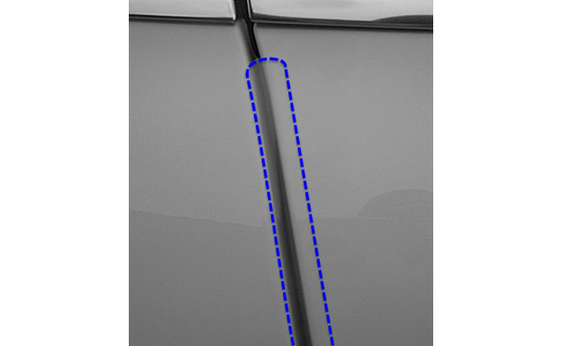
  - Align the film at the top of the door just below the window trim (about 0.25 inch below the window trim, Fig. 2-1).
Fig. 2-1
Centerline
NOTE: The centerline of the door edge film should be aligned with the edge of the door when looking at the door perpendicularly (Fig. 2-1).
  - If the vehicle does not have window trim to align the film to, choose the starting point for the film so that the ending point is roughly 0.25 inch from the bottom of the door.
NOTE: The centerline of the door edge film should be aligned with the edge of the door when looking at the door perpendicularly (Fig. 2-1).
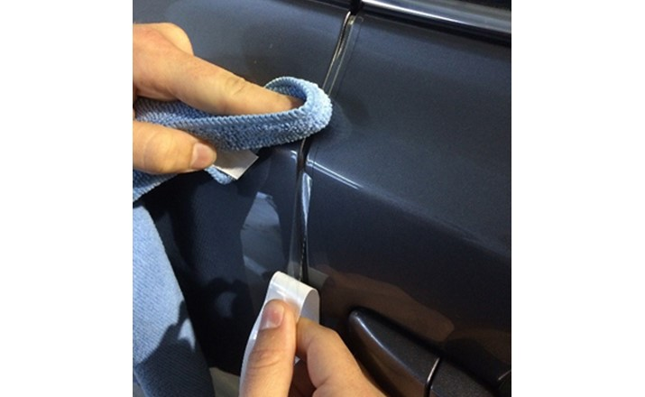
  - Starting at the top edge working down, use a finger to firmly wipe the film into place (Fig. 2-2).
  - Continue removing the film from the liner and working down the edge of the door. Use one hand to align the film, holding it taut, and thumb on the other hand to apply (bottom left, Fig. 2-2).
Fig. 2-2
NOTE: The film should stop 0.25 inch short of the lower edge of the door.
  - Use scissors to trim if necessary.
  - Open the door to proceed with the installation.
  - Wrap the film around the door edge, starting first at the major bends and character lines to ensure no bunching occurs on the back side.

  - Once the film at the character lines has been wrapped, proceed wrapping the rest of the film around the door edge with a finger tip, working from the top down.
NOTE: Be sure the film on the inside edge is fully sealed along the door length. A heat gun may be used to warm and reseal any areas of the film that may be lifting.
  - Check the surface for air bubbles or any other defects before continuing.
  - Repeat the process on the remaining doors.

Use and Care.
  - Clean the surface of the vehicle as necessary.
  - Remove the film if necessary.
    - Peel an edge corner of the material up. Grab enough material to allow a secure grasp by hand.
    - Pull the material at an angle between 30° and 45°.
    - Do not try to rip the material off the surface; instead, stretch the material off the surface.
NOTE: Stretching the material minimizes the amount of adhesive left on the vehicle surface.
    - Clean any adhesive left on the surface with adhesive remover.

Accessory Function Checks
Correct part number has been installed
Part is installed correctly
Film quality

Vehicle Function Checks

Verify the part number on the package
No loose edges, bubbles, and or film damage on either interior or exterior side of door
No scratches, correct edge alignment, and or debris under film

Vehicle Appearance Check
After accessory installation and removal of protective cover(s), perform a visual inspection.

Ensure no damage (including scuffs and scratches) was caused during the installation process.
(For PPO installations, refer to TMS Accessory Quality Shipping Standard.)

